**Konvertering af Tiff til Geo Tiff**

Use 'QLandkarteGT', an open source tool for CIS systems, [http://www.qlandkarte.org](http://www.qlandkarte.org/):

* From the top menu, select "Map", "Edit / Create Map".
* In the middle of the right half of the screen, a line with "Source: " appears, with an empty selection box. Click on the box, and select "Convert a TIFF into GeoTiff by geo referencing it".

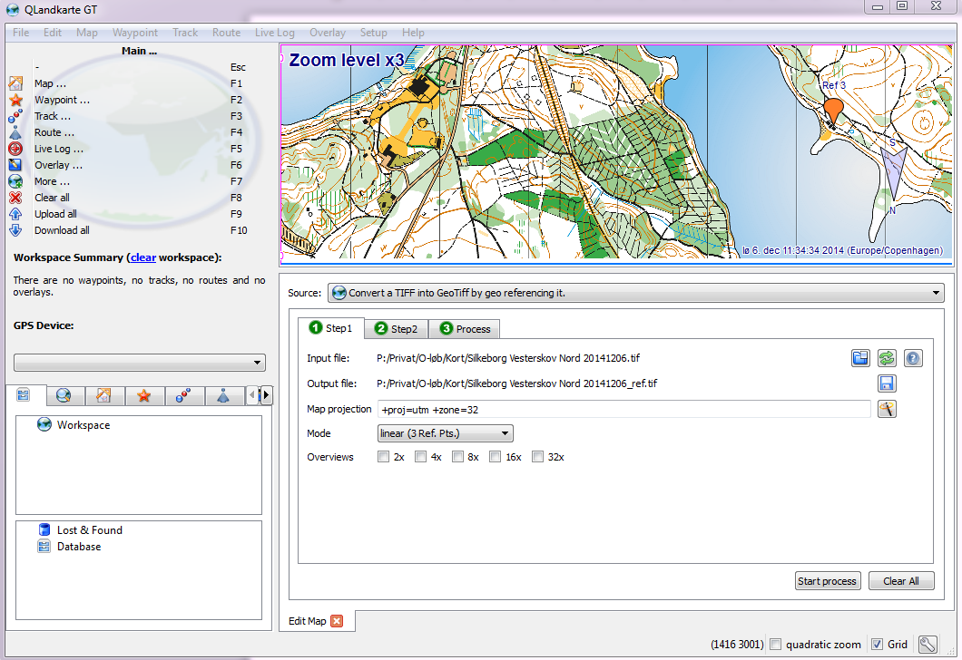

Now 3 steps appear below.

* In step 1, enter an input file by clicking to the icon to the right of "Input File" (this file can be a .PNG too), and use "+proj=utm +zone=32" for the Map projection.
* In step 2, click "Add Ref" (right column), move the pin to a known reference point on the map, and double click on "" in the "Coord" field, and enter the UTM coordinates in the form "533800 6223151" (for Vestre Søbad in Silkeborg)
  + repeat for at least 3 coordinates on the map (far apart from each other)
* In step 3, click on "Step 3: Process", and click on "Start Process"

Now it will create the GeoTIFF file.